  Test Plan

CMM 007 Story telling Web Application

Prepared By;

Olatunbosun Ayomide(2023)

**Abstract**

The goal of this project is to design a Story telling web app named CMM 007 Story telling App where users can log on or sign up to read travel stories. The stories are stored on SQL database and the web app is hosted on local area network (XAMPP). Users can access the bookstore web site through the World Wide Web. Users will be able to search the database to find the stories they want, check the availability, and download or add to the library. It is a two – user application.

One of the shortcomings of the project design is the inability to allow registered users to create stories on the web app.

**Design and Methodology**

In this project, several technical approaches are used:

* HTML language for WebPages design and implementation.
* SQL for relational database system.
* PHP technology for database connection.
* SQL, structured Query language is used to access and manipulate database.
* Java Script technology for client-server communication.
* Java Script Session tracking to implement the library
* Java URL class to implement the search the stories.
* Bootstrap

This project design is a web application and it provides a web-based interface. It is the graphical user interface. It have a form for user to input query information to search the database. The users interface then pass the input to the control function, which implemented in Java. The control function is designed to process the input from the users interface, generate the searching query and then gets data from the database and returns to the users interface. The control functions also have bridges to search some external real online bookstores. It can generate the query based on the user input and pass them to the commercial bookstore. The bridge can also handle the response from the commercial bookstore and parse the useful information and display to the user in HTML forms.

**Implementation**

**I. Database overview:**

The story telling database sit on the SQL is made of 6 tables.

**Books:**

Define the description, publisher, author, edition and pages of the stories.

**Categories:**

Defines the categories of the stories i.e. history, guidebooks and travels.

**Contact:**

**Shipping Details:** Defines the shipping details of the books.

**Subcat:** This defines the sub category

**User:** Defines the registered users.

**II. Java class file overview**

This project consists of a total of 17 java files

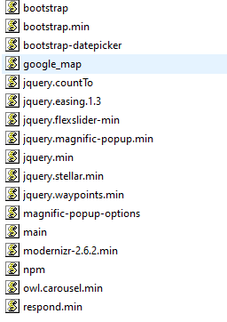

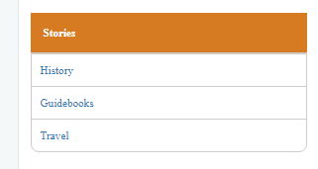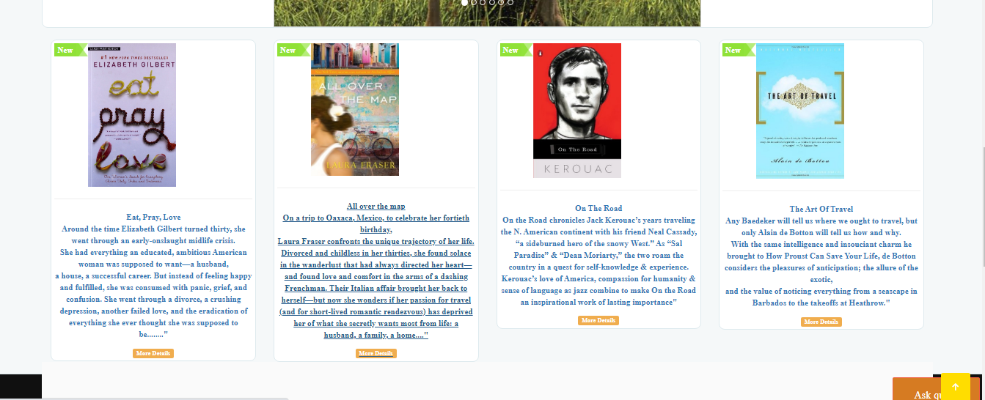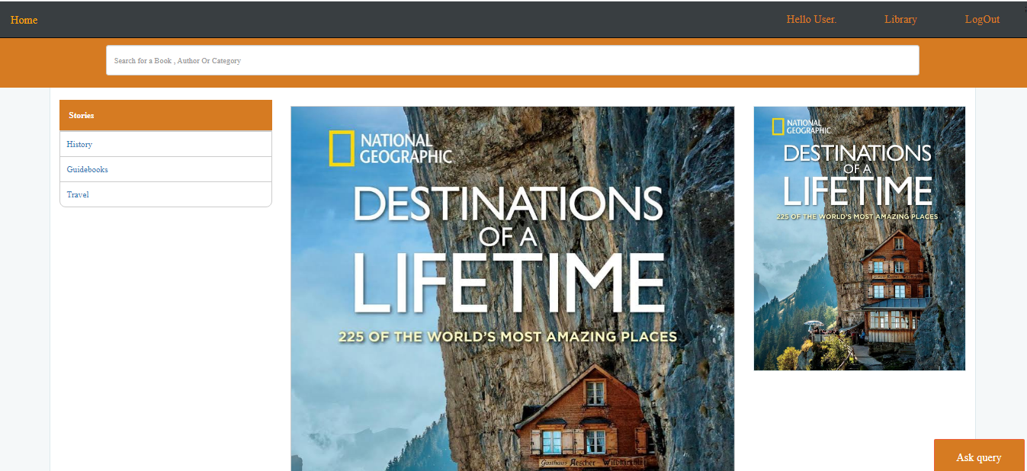

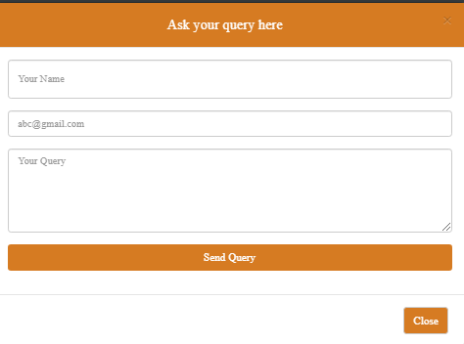

**LIMITATIONS OF STUDY**

1. TIME CONSTRAINTS
2. Inability to comprehend and understand what I learnt on MYSQL, JavaScript and PHP
3. Inability to complete project work. This project work was supposed to allow user to create their own stories but due to lack of understanding it was not included in the project.

**SUMMARY AND CONCLUSION**

This project is about designing a story telling web app with emphasis on traveling stories.

The project is a two-user website where by users can log in or register on the web app to read and stories.

The user interface is friendly and for this web app to be implemented different web programming languages and database server were used such as HTML, JavaScript, Bootstrap, PHP and SQL.

The web app was hosted on a local host (XAMPP) .

**REFERNCES**

1. Dick Oliver, **"Teach Yourself HTML 4 in 24 Hours",** Sams Publishing`, 1999
2. Douglas E.Comer, **"Computer Networks and Internets"**, Prentice Hall, 1998
3. Template retrieved from Code-projects.org, scribd.com
4. Demo pictures retrieved from unsplash.com, pexels.com, colorib.com
5. Demo books retrieved from google.com